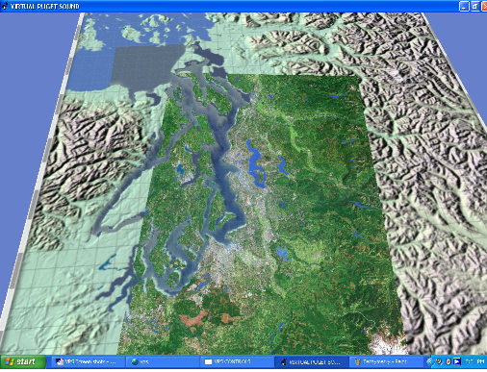
Figure 1 shows the image that appears when VPS-Desktop V3.0. has finished loading.
Figure 2 shows the VPS-Desktop V3.0. Controls panel (If it is closed, press “Enter” key to get it back)
Navigation (Perspective: first person shooter)
To change position, use the Location drop-down menu, top of the VPS Controls panel.
To fly, (change position and look around in the world) use the mouse:
- Move forward/backward or left/right, hold left button and slide mouse forward/backward or left/right.

- Move up and down, hold left and right button together and slide mouse forward or backward.
- Look up/down or left/right, hold right button and slide mouse forward/backward or left/right
Features and Functions
1. View Options in Figure 2
1.1. Circulation Vector (Fig. 3): Options include scale and data options (x, y, z)
1.2. Tide Chart (Fig. 4): check the box and click to select one location to see the tidal
change during a day. In the mean time, check the box START in Time options.
1.3. Data Panel (Fig. 5): Salinity ppt, speed m/s, compass direction, depth (m), time (hr).
1.4. Cut Planes (Fig. 6): Horizontal and Vertical representation of salinity, temperature in
water column.
2. Particles Options in Figure 2
2.1. Point Source option: Release Particles button releases a continuous stream of particles
from individual locations marked by “buoy.”
2.2. Grid option: Release Particles button simultaneously releases a suite of particles initially positioned at equidistant surface locations from each other.
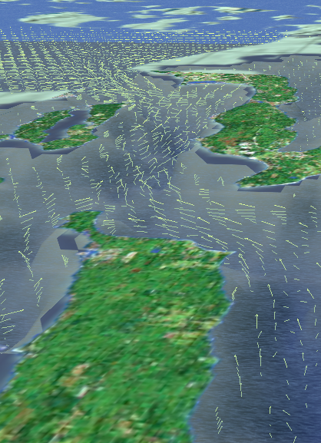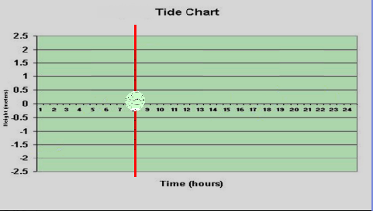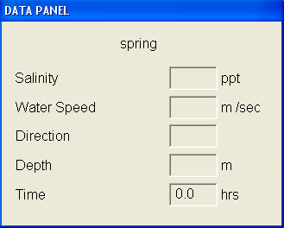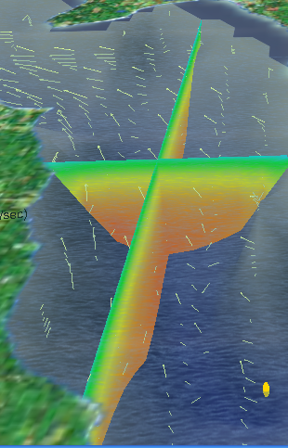
Fig. 3: Circulation Vectors Fig. 4: Tide chart Fig. 5: Data Panels Fig.6: Cut planes
Figure 1: Virtual Puget Sound-
Initial view of the VPS world.

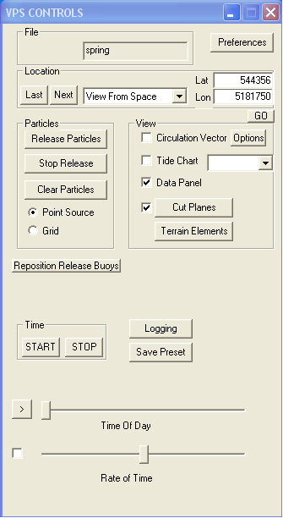
Figure 2: VPS Controls Panel

3. Parameter Cut Planes (Figure 7)
  - Click on to select “Salinity” or “Temperature”, top of the Parameter Cut Planes panel.
  - To turn on the horizontal cut plane, check the box Horizontal Plane on (default setting); drag the Depth slider up(surface) and down (bottom) to change the depth.
  - To use vertical cut planes, uncheck Horizontal Plane on and then drag the slider of “East-West Plane” up and down or “North-South Plane” left and right to change the location of cut planes
  - Parameter setting of salinity: 20-28 is a good start but best visualization will depend on model data being used.
  - Parameter setting of temperature: 14-19 is a good start but best visualization will depend on model data being used.
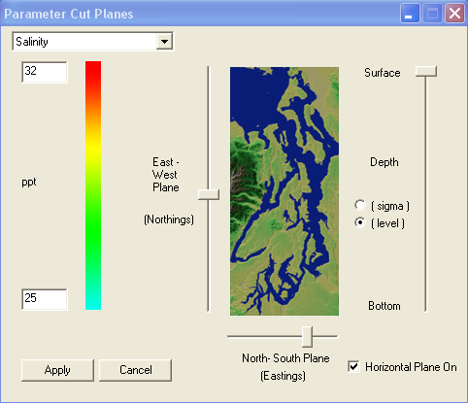
Figure 7: Parameter Cut Planes

